Computing a Restricted Partition

Kevin Dittmar and Abdul Hassen
Department of Computer Science and Department of Mathematics
Rowan University
Glassboro, NJ 08028
dittma75@students.rowan.edu‬‬‬‬‬‬‬, hassen@rowan.edu

Abstract
A partition of a positive integer is the number of ways in which the integer can be written as a sum of positive integers. In this paper we will consider a partition of a positive integer in which the smallest part is a given integer. This is an example of what is known as restricted partition. We use a known recurrence formula of the restricted partition under consideration and reduce this recurrence to a well known partition function. We then develop a C program to construct a table of values for the restricted partition.
Key words: Partition function, restricted partitions, recurrence relation.
2000 Mathematics Subject Classification. Primary 11P84

1. Introduction

A partition function is the number of ways of expressing a given positive integer as a sum of positive integers. For example, 5 can be expressed as a sum of positive integers in 7 different ways:
Such a partition is called unrestricted partition. The number of unrestricted partition of a positive integer is denoted by 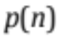. Thus, by listing the number of ways we can write the first five positive integers as a sum of positive integers, we can see that
But to find 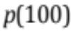 in this manner is nearly impossible. There are some methods to generate the values of for large values of For a readable exposition of such a method, we recommend [2]. We also recommend [1] for further reading.
The other types of partition that one can study include the partition of a positive integer in which each summand is distinct. For example 5 has 3 distinct partitions:
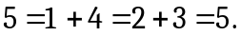
If we denote by 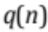 the number of partitions of into distinct parts, then, by actual enumerations, we can see that
Again computing the values of by enumerations are almost futile when is very large.
In this paper, we focus on the partitions of n with least part m and denote it by 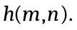 Counting the number of partitions algorithmically is a particularly difficult endeavor. Our goal here is to give an outline of a method to compute 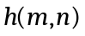 as our main restricted partition. In Section 2, we will describe a recurrence formula and explain how this formula can be reduced to the simplest form. In Section 3, we give an explanation of the computer program we have developed to compute 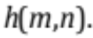 In the last section, we will mention how our program can be modified to compute other restricted partitions.

2. The Restricted Partition 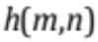

Chandrupatla, Hassen, and Osler in [1], showed that the restricted partition satisfies the recurrence relation
(1)
Repeated applications of (1) will allow us to evaluatefrom the values 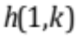 for smaller values of 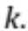 To this end, we will create a tree in which the top point (or first row) is Then we use equation (1), to create the second row which is made up the two elements 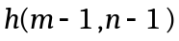 and 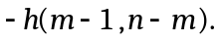The next row below this will now have four entries, two for each of the summands appearing in (1) corresponding to elements and 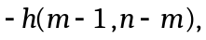respectively. Every subsequent row has twice as many elements as the previous row until the elements in the row are of the form 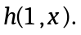 Clearly this takes steps. Note then that the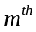 row will have 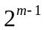 elements. The elements of the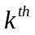row will be referred to as leaves of the decomposition tree from this point on. The following tree represents a decomposition tree for 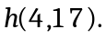

It follows that
We shall refer to such a diagram as a tree and the elements in each row as elements. Notice that the bottom row is of the form 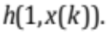 The bottom left most entry 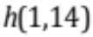 will be denoted by 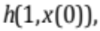 so that 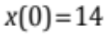 in this example. We shall describe how to generate the other values of 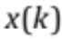 in the last row shortly. But first we will make some observation about the signs of each element in a given row.
The elements in the second row are positive and negative, respectively. For the next row, the entire preceding row will be repeated followed by a duplicated copy with opposite signs. In other words, the signs of the elements on a tree will look like
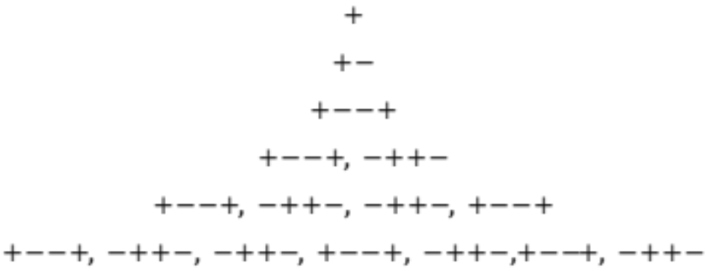
Such a pattern is common in areas unrelated to partition function. For instance, if + and – are replaced by 0 and 1, then we have what is known as Thue-Morse function.
Let us define 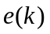to be the sign of the 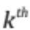 element of the bottom row of the tree. We observe that 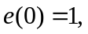 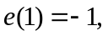and
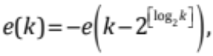
where 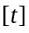 denote the largest integer less than or equal to Let each element at the bottom row of the decomposition tree of be denoted as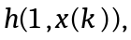 where 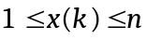and 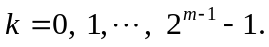 Note then that
(2) 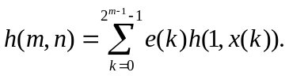
In the 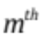 row, the left most element is 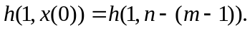 Hence 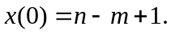 For 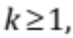 can be computed using the reduction formula
(3)
where 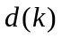 is defined by the recurrence formula
and 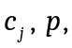and 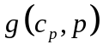 are defined by
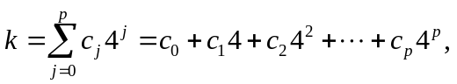
with 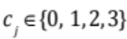, 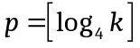and
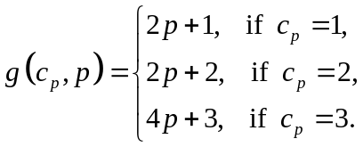
For example to compute 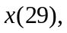 we first write 29 as 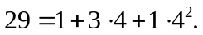 This implies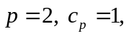 and hence
But then 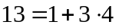implies that 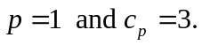 Thus
Combining these values we conclude that 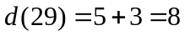 and hence 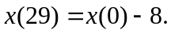
To make use of (2), we observe that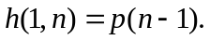 To see this, we note that if 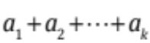 is a partition of 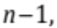then 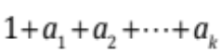is a partition of in which the smallest part is 1, and conversely. It is well known that the unrestricted partitions can be expressed in the form
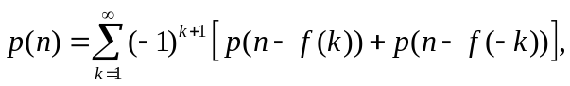
where 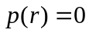 for 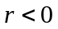 and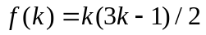 represents the pentagonal number. (An easy derivation of this formula can be found in [3].) Thus, we express 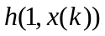 as
(4) 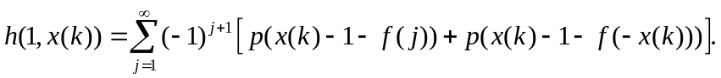
We now use equations (2), (3), and (4) to compute The following tables contain the values of for some values of and along with the time needed for computation. We have included the entire computer program available online at https://github.com/dittma75/partitions.
m | N | h(m,n) | time(s) |  | m | n | h(m,n) | time(s)
4 | 10 | 1 | <1 |  | 1 | 1000 | 2.31278E+31 | 0.453
4 | 20 | 11 | 1 |  | 2 | 1000 | 8.63387E+29 | 0.75
4 | 30 | 70 | 1 |  | 3 | 1000 | 6.25475E+28 | 1
4 | 40 | 371 | 1 |  | 4 | 1000 | 6.59986E+27 | 1
4 | 50 | 1668 | 1 |  | 5 | 1000 | 9.02274E+26 | 2
4 | 100 | 805158 | 1 |  | 6 | 1000 | 1.49931E+26 | 4
4 | 500 | 1.53988E+18 | 1 |  | 7 | 1000 | 2.90901E+25 | 8
4 | 1000 | 6.59986E+27 | 1 |  | 8 | 1000 | 6.4112E+24 | 17
4 | 10000 | 4.0478E+101 | 1 |  | 9 | 1000 | 1.57318E+24 | 34
4 | 100000 | 1.0581E+340 | 1 |  | 10 | 1000 | 4.23324E+23 | 68
4 | 999999 | 1.8375E+1099 | 1 |  | 15 | 1000 | 1.68718E+21 | 2198
 |  |  |  |  | 400 | 1000 | 1 | 0.15

3. Concluding Remarks

We note that the method discussed in the previous section can be used to compute the values of 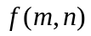 that satisfies the recurrence relation in the form
where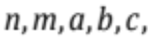 and are positive integers, and has a prescribed initial values. In the case of 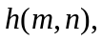the initial values are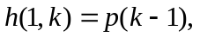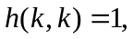and 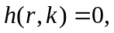where and are positive integers with 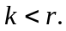
As another example, consider the restricted partition 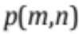 of in which the largest part is Note then that has initial values 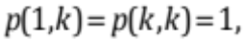 for any and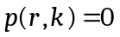 for 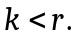 It is known that 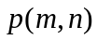 satisfies the recurrence formula
Below is the tree generated by expanding the recurrence relation for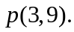
p(3,9)
p(2,8)
p(3,6)
p(1,7)
p(2,6)
p(1,5)
p(2,4)
p(1,3)
p(2,2)
p(3,3)
p(2,5)
p(1,4)
p(2,3)
p(1,2)
p(2,1)

By the initial conditions, we have 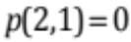 and 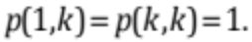 (These are the terms in red and yellow, respectively. Since there are seven valid elements at the ends of the tree’s “branches”, we conclude that
The seven partitions are
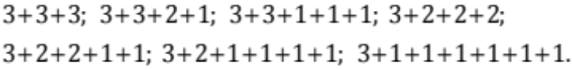

References
- Andrews, G. (1994), Number Theory, Revised Edition, Dover Publications, New York, (ISBN-13: 978-0486682525).
- Chandrupatla , T. R, Hassen, A., Osler, T (2001/2002), A Table of the Partition Function, The Mathematical Spectrum, 34, pp. 55 - 57.
- Hassen, A., Osler, T. (2001), Playing with Partitions on the Computer, Mathematics and Computer Education, 35(2001), pp. 5 – 17. (ISSN 0730-8639)

